KR2-S Operating Manual

N1852Z

Sep 7, 2006

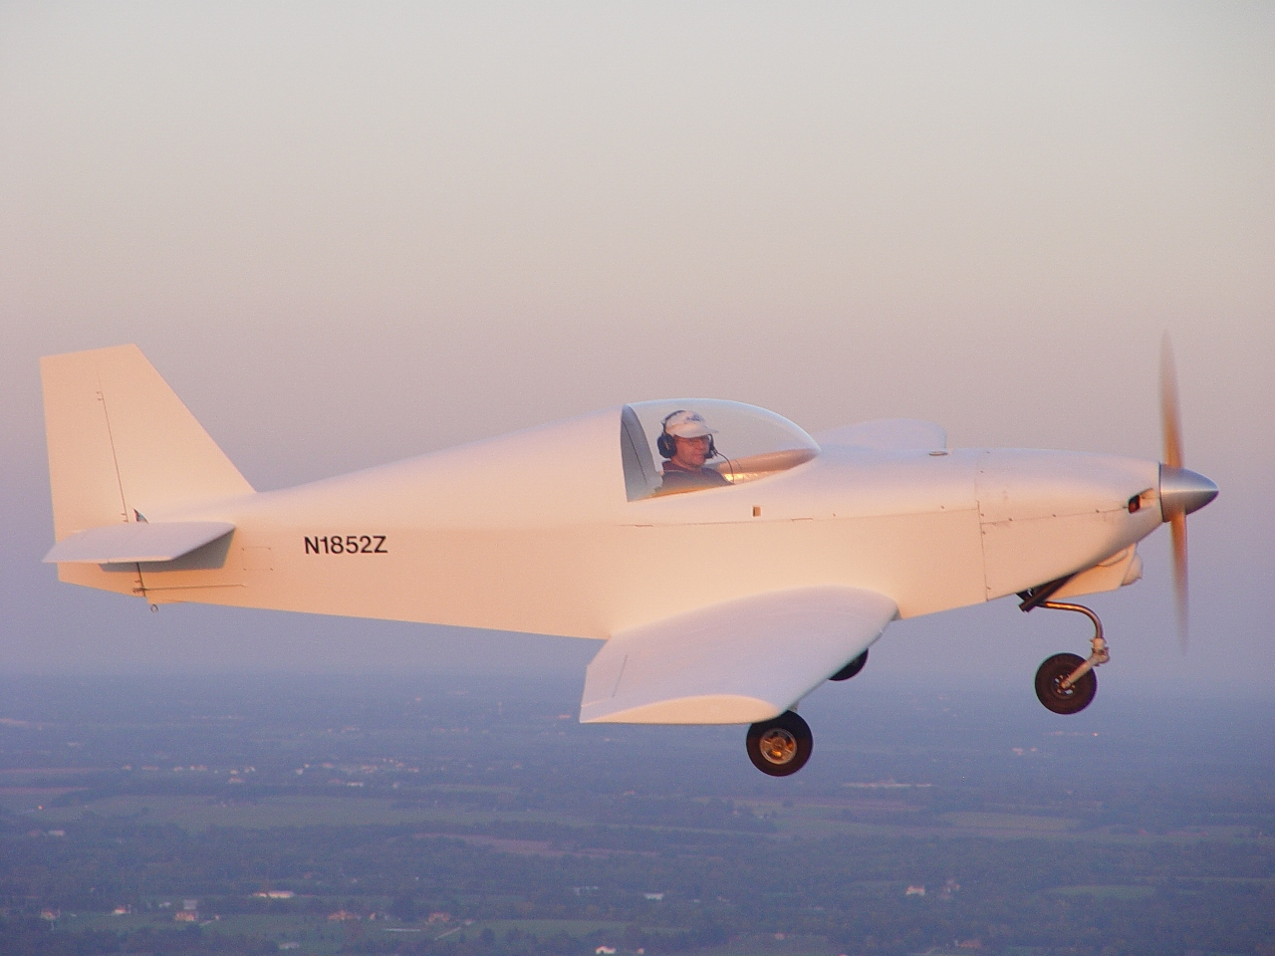

TABLE OF CONTENTS

SECTION PAGE

DESCRIPTION OF SYSTEMS & STRUCTURES 3
OPERATING PROCEDURES 6
OPERATING LIMITATIONS 7
PERFORMANCE CHARTS 10
EMERGENCY PROCEDURES 12
CARE of the AIRCRAFT 15
KR2-S CHECKLISTS 18

DESCRIPTION OF SYSTEMS & STRUCTURES

DESCRIPTIONS AND INTRODUCTION

The KR2-S is a high-performance, homebuilt aircraft. Its compact external size and extremely efficient design results in superb performance and unequaled fuel economy using a relatively low horsepower engine. Pitch control is provided by elevators mounted on the horizontal stabilizer. Roll capability is provided by ailerons on the outboard portion of the main wing. Yaw control is provided by a rudder mounted on the vertical stabilizer, and is actuated by conventional rudder pedals. The pitch and roll capability is provided by a center stick controller located in the center of the cockpit. This feature permits precise control of the KR2-S while reducing pilot fatigue and cockpit clutter.
The nose gear steering is provided by differential braking. providing positive steering at all times while on the ground. Even though the KR2-S has relatively low horsepower, it can outperform many general aviation aircraft while retaining unequaled fuel economy. The maximum speed is 200 m.p.h., and the fuel economy exceeds 30 miles per gallon.
The structure of your KR2-S provides some important advantages over conventional all metal , wood, or fabric construction. Contour is maintained under load; the structure does not "oil can", buckle, or distort. It provides excellent insulation and damps noise. It has no hidden joints, no water traps, and is far less susceptible to corrosion. It is easier to inspect and easier to repair. It is not susceptible to thermal stress due to temperature changes. Properly protected from UV, it has an unlimited life.
The engine that powers the KR2-S is a Revmaster 2100 D aircraft engine. This engine features a forged steel crankshaft, dual magneto ignition, mixture control, alternator, and electric starter.

INSTRUMENT PANEL

The instrument panel is mounted to the fuselage. Sufficient room is provided in the instrument panel for mounting day and night VFR equipment.

HEATING AND VENTILATION

Fresh air ventilation is provided by vents in the canopy The flow of air can be controlled by adjusting the inlet opening with the knob on the inside of canopy. The composite aircraft structure has very good insulating properties. A cabin heat muff using the engine exhaust system provides added heat for the cockpit.

LANDING GEAR

The main landing gear is a composite structure that is attached to the back of the main spar. The nosegear is supported by the firewall and engine mounts. The nose gear is full castoring and is steered by differential braking, resulting in very positive directional control while taxiing, and during takeoff and landing.

BAGGAGE COMPARTMENT

A baggage compartment is provided aft of the occupants heads. The baggage limit is 35 pounds. Depending on the pilot, passenger, and fuel to be carried, baggage may have to be limited because of gross weight or center-of-gravity (c. of g.) limits.

FLIGHT CONTROLS

Pitch and roll control is actuated by a center stick located to the right of the pilot. The rudder pedals are conventional. The ailerons are actuated by cables. The rudder and elevators are actuated by cables.
A fixed - ground adjustable pitch trim system is provided. Also, it should be noted that the primary pitch control system (i.e. the stick) can override any position of the trim system.

ENGINE CONTROLS

The throttle, located in the left of the instrument panel, is equipped with a friction lock to prevent creeping (but which can be overridden manually). The carburetor heat control and the mixture control are also located in the left of the cockpit. All three are of the push-pull type.

BRAKES

The braking system consists of hydraulic disk brakes on each main tire, actuated by individual heel brakes inside the cockpit. Only the pilot's side has heel brakes.

FUEL SYSTEM

The 17 gallon main fuel tank is located just aft of the firewall above the occupant's legs. The unusable fuel quantity is less than 1/2 gallon. The engine is gravity fed from the header tank, with a fuel shutoff valve located underneath the fuel tank. The fuel tank has a mechanical float gauge to measure fuel quantity with readout on the instrument panel.

The fuel filler cap is provided on the upper forward fuselage, accessible from the outside of the aircraft. Only 100 octane Aviation fuel is recommended.

ELECTRICAL SYSTEM

OPERATING PROCEDURES

BEFORE STARTING

Before starting, be sure that the engine is properly filled with oil. Fuel should be 100 LL octane Aviation gasoline.

STARTING

At normal temperatures, the engine should start with the throttle cracked 1/2"
Problems encountered during starting are almost always caused by flooding.

TAKEOFF

The KR2-S should be allowed to accelerate to approximately 65. The aircraft will lift off at about 65 mph. You may desire to amend this sequence when the winds are strong and gusty. In order to leave a larger margin for abrupt gusts right after liftoff, a liftoff speed of 70-75 mph is sufficient.

CLIMB

Best rate-of-climb speed varies from 85 mph at S.L. to 78 mph at 10,500 ft. The best angle-of climb is 78 mph at S.L. Recommended normal climb speed is 90 mph.

CRUISE

Recommended maximum normal cruise RPM is 3200 rpm.

Continuous use of carburetor heat during cruising flight decreases engine efficiency, and is not recommended. Use carburetor heat only as necessary. When applying carburetor heat, do so slowly to the full on position at intervals to determine if ice has developed.

GENERAL FLYING QUALITIES

See the section entitled "Low Speed Flying Qualities" for information on that portion of the operational envelope.

The control forces on the KR2-S, while somewhat lighter than say, a Grumman Tiger, are not overly sensitive. The center stick function allows more accurate inputs with less fatigue and less cockpit clutter.

Flying in visible moisture can result in an increase in stick force and a small change in elevator angle at a given trim speed. When first encountered, this phenomenon can be disconcerting to the pilot because of the increase in stick force.

Continuous flying in rain may cause erosion of the fixed pitch wood prop.

At high speeds and aft center of gravity locations, a mild 'tucking' of the nose can be noted when the aircraft is allowed to depart in pitch. This tucking will not be noted in normal straight and level flight, and is indicated here for the benefit of pilots intending to explore the outer reaches of the performance envelope.

LANDING

A final approach speed of 80 mph should be used under normal conditions.

The visual cue available from the main gear minimizes any tendency to "drop" the aircraft in. However, until one is comfortable in the aircraft, one should be extra cautious about flaring too high and dropping the aircraft in from above 3 feet. This is due to the fact that the pilot in a KR2-S sits much closer to the ground than what he is accustomed to any conventional certified aircraft.

A short field landing should be made with an approach speed of 70 mph. A speed lower than 70 mph may cause difficulty in flaring if the round out is started too high and the pilot attempts to correct it.

Crosswind landings in the KR2-S are easy. A conventional "wing low" approach should be used, permitting the upwind main wheel to touch first. The other main gear will lower and touch gently.

SLIPS

Slips are very effective. Rapid descents with high sink rates can be obtained through a properly executed slip. It is recommended, however, that slips be practiced at altitude until the pilot is familiar with the aircraft. The recommended slip speed is 90 mph. Pilots should make themselves familiar with the aircraft at a variety of slip speeds.

OPERATING LIMITATIONS

The KR2-S is intended for day and night VFR operation with standard equipment installed. Operation should be in accordance with all markings, placards, and check lists in this Operating Manual.

UTILITY CATEGORY OPERATION

The KR2-S is intended to be operated in the utility category. The utility category is restricted to airplanes intended for limited acrobatic operation within the flight load factor limitations listed below. The following utility category maneuvers are approved:

1. Any maneuver incident to normal flying.
2. Minimum speed maneuvering with full aft stick.
3. Lazy eights, chandelles, and steep turns.

MAXIMUMS
Gross Weight 1100 lbs.
Maneuvering Speed 134 mph
Flight Load Factors +4.4g, -1.76g

ACROBATIC LIMITATIONS
Maneuver Maximum Entry Speed
Chandel1es 134 mph
Lazy Eights 134 mph
Steep Turns 134 mph

AIRSPEED LIMITATIONS

Maximum Glide or Dive,
Smooth Air (Red Line) 200 mph
Maneuvering Speed 134 mph
Caution Range (Yellow Arc) 146-200 mph
Normal Range (Green Arc) 64-146 mph

ENGINE INSTRUMENT MARKINGS

Oil Temperature Gauge -
Normal Operating Range
(Green Arc) 160-220F
Yellow 220-260F
Red 260F
Oil Pressure Gauge -
Normal Operating Range 30-60 PSI at 2700 rpm
Maximum Allowable 90 PSI
Yellow 20-30 PSI
Red 20 PSI
Cylinder Head Temperature (If Installed) -
Normal Operating Range 300-450F
Yellow 450-500F
Red 500F

Tachometer -
Normal Operating Range 2700-3200 RPM
Maximum Allowable 3400 RPM
Voltmeter -
Normal Operating Range 13.5-14.5 Volts

WEIGHT AND BALANCE

The following information defines the weight and center-of-gravity range of this specific KR2S.

SAMPLE LOADING

 |  |  |  | Determined From:
 |  |  |  | Manuf Data | My Data
Datum Location: | FIREWALL = 0 |  |  |  | X
Leveling Means: | BUBBLE LEVEL |  |  |  | X
Total Fuel Capacity: | 17 GALLONS |  |  |  | X
Max Gross Weight: | 1100 |  |  |  | X
CG Range: | 22.5 - 30.5 |  |  | X
Empty Weight & CG | Weighing Point | Weight (lbs) | Arm (in) | Moment  (in-lbs)
Left main wheel | Scale reading: | 199 | 33 | 6567
Left main wheel | Tare: |  | 33 | 6567
Left main wheel | Net weight: | 199 | 33 | 6567
Right main wheel | Scale reading: | 202 | 33 | 6666
Right main wheel | Tare: |  | 33 | 6666
Right main wheel | Net weight: | 202 | 33 | 6666
Tailwheel or nosewheel | Scale reading: | 199 | -9 | -1791
Tailwheel or nosewheel | Tare: |  | -9 | -1791
Tailwheel or nosewheel | Net weight: | 199 | -9 | -1791
 | Empty weight/CG: | 600 | 19.07 | 11442
Most Aft Loading | Item | Weight (lbs) | Arm (in) | Moment  (in-lbs)
 | Aircraft empty: | 600 | 19.07 | 11442
 | Pilot: | 170 | 45.25 | 7692.5
 | Passenger: | 170 | 45.25 | 7692.5
 | Baggage: | 35 | 68 | 2380
 | Fuel: | 35 | 13 | 455
 | Weight/CG | 1010 | 29.37 | 29662
Most Fwd Loading | Item | Weight (lbs) | Arm (in) | Moment  (in-lbs)
 | Aircraft empty: | 600 | 19.07 | 11442
 | Pilot: | 170 | 45.25 | 7692.5
 | Passenger: |  | 45.25 | 0
 | Baggage: |  | 68 | 0
 | Fuel: | 98.6 | 13 | 1281.8
 | Weight/CG | 868.6 | 23.50 | 20416.3
Flight Test Loading | Item | Weight (lbs) | Arm (in) | Moment  (in-lbs)
 | Aircraft empty: | 600 | 19.07 | 11442
 | Pilot: | 170 | 45.25 | 7692.5
 | Passenger: |  | 45.25 | 0
 | Baggage: |  | 68 | 0
 | Fuel: | 98.6 | 13 | 1281.8
 | Weight/CG | 868.6 | 23.50 | 20416.3

Check - Gross Weight vs. inside Operating Moment Graph; Loading is inside C.G.
Envelope

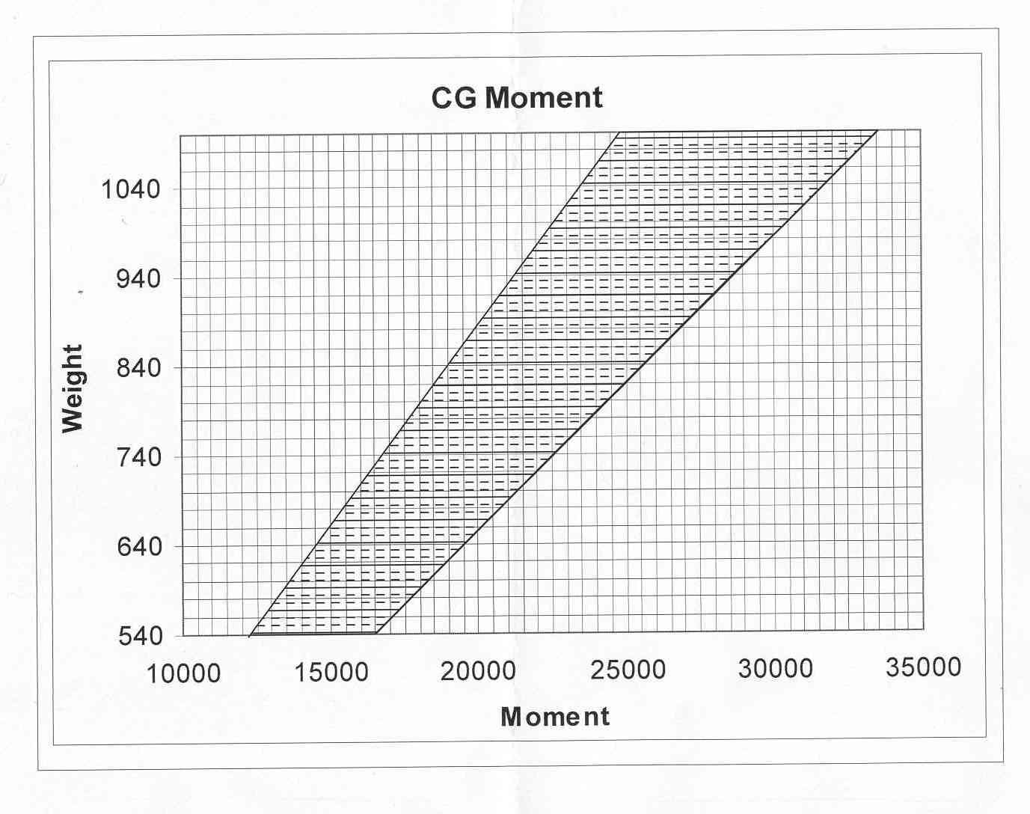

PERFORMANCE CHARTS

Performance information has been derived from actual flight tests on the KR2-S and corrected to standard atmospheric conditions at 1100 pounds maximum gross weight.
Actual performance will vary from standard due to variations in atmospheric conditions, engine and propeller condition, mixture leaning technique, and other variables associated with the particular performance item.

AIRSPEED

Vtrue | Engine | Indicated
(mph) | RPM | Airspeed
110.0 | 2800 | 105
115.9 | 3000 | 112
123.0 | 3200 | 120

Gross weight Range
1,100 pounds Maximum cruise: @ 120 MPH 360 miles
Fuel capacity with 45 minutes reserve
17 gallons Economy cruise: @ 105 MPH 400 miles
Engine with 45 minutes reserve
Revmaster 2100 D Minimum speed
Horsepower 50 miles/hour (800 pounds)
75 horsepower © 3400 rpm
Top speed Rate of climb (Sea Level)
200 miles/hour 800 feet/minute (870 pounds)
Fuel economy 600 feet/minute (1100 pounds)
Maximum cruise:
33 miles/gallon Ceiling
Economy cruise: 15,000 feet (1100 pounds)
40 miles/gallon
Takeoff distance (Sea Level)
350 feet (800 pounds)
Landing distance (Sea Level)
600 feet (800 pounds)

EMERGENCY PROCEDURES

BRAKE FAILURE

Although brake failure is infrequent in any aircraft, landing without brakes is no problem If a brake failure is detected, proceed to the nearest airport with adequate runway length to accommodate a landing without brakes. It is recommended, with a single brake failure that neither brake be utilized during landing and roll-out. Plan the touchdown near the approach end of the runway. The aircraft nose should be aligned with the runway centerline. Use minimum safe airspeeds for existing conditions. Maintain directional control straight down the runway with steering. Allow the airplane to roll to a stop without the use of brakes. The engine may have to be stopped to reduce the ground roll. Push or tow the aircraft to a facility for repair.

MINIMIZING THE GROUND ROLL ON LANDING

Under normal conditions, to minimize the landing ground rollout, touchdown at the minimum speed, maintain directional control, and apply brakes until the plane stops. A further reduction in ground rollout can be obtained by shutting the engine off using the ignition switch.

EMERGENCY LOCATOR TRANSMITTER

An ELT is installed.

ICING CONDITIONS

Carburetor ice may be encountered at any time, even with ambient temperatures of 80 F. The first indication of carburetor ice should be a slight drop in engine RPM. Slight engine roughness may or may not accompany this engine RPM drop. If carburetor icing is suspected, the following procedures are suggested:

- Slowly apply full carburetor heat. Engine roughness may then occur due to an over-rich mixture or water from the melting ice.

2. Continuous engine operation with carburetor heat ON is not recommended due to the decrease in engine efficiency.

CAUTION: Flying in known icing conditions is not only prohibited by FAA regulations, but it is also very foolish. However, should wing icing occur, the following procedures are suggested:

1. Monitor engine RPM for any indication of carburetor ice.
2. Increase airspeed if possible to reduce the angle of attack.
3. Changing altitude or course may alter the rate of accumulation of ice.
4. Remember that ice accumulation increases wing loading, decreases performance, decreases range and increases stall speeds. When landing, plan a slightly higher than normal air speed during landing approach. Guard against the increased stall speed created by the above mentioned conditions.

REMEMBER: Flying in icing conditions should be avoided.

WINDSHIELD OBSCURATION

A windshield obscuration caused by ice or moisture condensation should not be encountered while flying day or night VFR. If it is encountered, open all vents, turn cabin heat ON if installed, and change altitude, if possible, in order to alter the outside air temperature. If part of the windshield is clear, a slip may be used to keep the airport in sight during the approach and landing.

LOW OIL PRESSURE/ENGINE OVERHEAT

A low oil pressure reading may be caused by malfunction of the indicating system, oil pump failure, or loss of oil. Monitor the oil temperature gauge for a marked increase in temperature. If no temperature change is detected, the failure may be in the oil pressure indicating system. Proceed to the nearest airport, land, check the oil level, and determine the difficulty. In flight, if the oil pressure indication is low and is confirmed by high oil temperatures, reduce power and proceed to the nearest airport or suitable landing area and land. If possible, notify the nearest ATC radio facility of your difficulty.

CAUTION: Lack of oil pressure will cause the engine to seize, requiring replacement or repair. Do not expect engine to continue operating while in-flight. When operating in high outside air temperature, the oil temperature may approach the red line. This is not detrimental and is not cause for concern unless the oil temperature exceeds the red line on the oil temperature gauge. A reduced power setting will lower the oil temperature; should it exceed the red line in flight, land at an airport and correct the problem.

INFLIGHT ENGINE FIRES

In-flight engine fires in today's modern aircraft are extremely rare and it should be noted that the presence of smoke does not always mean that a flaming fire exists. As an example, it may be engine oil on the exhaust system. If, in the pilot's judgment, an engine fire exists the following procedures are suggested:

1. Fuel selector - OFF
2. Magneto switches - OFF
3. Establish a maximum safe rate of descent. Increasing speed may blow the fire out.
4. Side slip maneuvers may be used, as necessary, to direct flames away from the cabin area.
5. Select a suitable field for a forced landing.
6. Notify ATC of your location and problem, if possible.
7. Master switch - OFF
8. Complete the forced landing; do not try to restart the engine.

INFLIGHT ELECTRICAL FIRES

Indication of in-flight electrical fires may be wisps of smoke or the smell of hot or burning insulation. Should an electrical fire develop, the following procedures are suggested:

1. Master switch - OFF
2. All Electrical switches - OFF
3. Cabin heat vent (s) - OFF
4. Proceed to nearest suitable airport for landing.

CAUTION: If electrical power is necessary for safety of flight, attempt to isolate the electrical problem and turn that unit off.

ENGINE ROUGHNESS

If a rough-running engine is encountered, it may be for any one of the following reasons:

1. Lead or oil fouled spark plugs.
2. Incorrect fuel/air mixture.
3. Incorrect use of carburetor heat.

Some roughness at high altitudes may be encountered if the mixture control is not used to lean the air mixture.
Spark plugs may become oil-fouled during taxiing, prolonged power-off descents, or cruising with an improper fuel-to-air mixture. The majority of engine roughness encountered is due to fouled spark plugs. This may be eliminated by removing the spark plugs and cleaning them.
Improper use of carburetor heat also may induce engine roughness. Abrupt application of carburetor heat when cruising above 5,000 MSL may result in momentary engine roughness. This condition is caused by warm air being fed into the carburetor. Warm air is less dense and tends to upset the fuel/air ratio, thus causing an over-rich mixture condition. Returning the carburetor heat to OFF will tend to correct this condition. It may be necessary, from time to time, to fly with partial carburetor heat. Adjust mixture for smooth operation.

NOTE: Flying with partial carburetor heat is not recommended unless the aircraft has a functioning carburetor air temperature gauge installed.

ENGINE FAILURE

Engine failures are very rare in modern aircraft. Should an engine failure occur, the basic procedures listed below may be a useful guide:

1. Establish a glide speed of 90 mph.
2. Check wind direction for landing.
3. Pick a suitable landing area and plan an approach.
4. Carburetor Heat - ON
Magneto Switches - OFF, then ON
Starter switch - ON
- If the engine does not start promptly, attention should be shifted to the forced landing
procedure.
6. Notify ATC of your location and problem, if possible.
7. Fuel Valve - OFF
Magneto Switches - OFF
Master Switch - OFF
8. Complete the landing and secure the aircraft. Notify ATC by telephone of your location, the aircraft situation, and location.

ELECTRICAL SYSTEM MALFUNCTION

The voltage reading will vary depending on the current drain from operating equipment. Check the alternator and regulator for malfunction and control equipment usage.

CARE of the AIRCRAFT

COMPOSITE STRUCTURE

The KR2-S is painted with a primer that contains a barrier for ultra-violet radiation. This, or an equivalent UV barrier, is required to protect the epoxy and foams from deterioration. Do not expose unprotected fiberglass to sunlight for extended periods. Unpainted areas should be retouched. The high surface durability and high safety margins designed into the KR2-S make it highly resistant to damage or fatigue. If the structure is damaged, it will show up as a crack in the paint. The strain characteristics of the material are such that it should not fail internally without first failing the paint layer. If damage is apparent due to a crack in the paint or wrinkle in the skin, remove the paint around the crack by sanding and inspect the glass structure. Do not use enamel or lacquer paint remover. If the glass structure is damaged, it will have a white appearing ridge or notch indicating torn (tension) or crushed (compression) fibers. If there is no glass damage, it will be smooth and transparent when sanded. If there is glass structure damage, repair as shown in the KR2-S Construction Plans. De-laminations are rare, due to the proper design of joints (None have occurred on the prototype.) If a de-lamination occurs (skin trailing edge joints, etc.), spread the joint, sand the surfaces dull , trowel in wet flox, clamp back together, and let cure.

PROPELLER CARE

Since wooden propellers do not have "metal fatigue" problems, they are a lot more forgiving of nicks. However, whenever you notice a large nick, you should sand it out and refinish and rebalance the prop. Waxing the propeller regularly will also help protect the surface. Flying regularly in rain may erode the leading edge of the propeller.

EXTERIOR CARE

Consult the manufacturer of the paint that you used, or his representative, to determine the best means of maintaining a bright exterior surface.

CANOPY CARE

It is recommended that you keep the Plexiglas in the canopy clean and unscratched. The following procedures are recommended:

1. If large deposits of mud and/or dirt have accumulated on the Plexiglas, flush with clean water. Rubbing with your hand is recommended to dislodge excess dirt and mud without scratching the Plexiglas.
2. Wash with soap and water. Use a sponge or heavy wadding of a soft cloth. DO NOT rub, as the abrasive action in the dirt and mud residue will cause fine scratches in the surface.
3. Grease and oil spots may be removed with a soft cloth soaked in kerosene.
4. After cleaning, wax the Plexiglas surface with a thin coat of hard polish-wax. Buff with a soft cloth.
5. If a severe scratch or marring occurs, jeweler's rouge is recommended. Follow directions, rub out the scratch, apply wax and buff.

NOTE: Never use benzene, gasoline, alcohol, acetone, carbon tetrachloride, lacquer thinner or glass cleaner to clean plastic. These materials will damage the plastic and may cause severe crazing.

ENGINE OIL

Check engine oil level on each flight prior to operating the engine. Do not mix brands, nor grades of motor oil. Recommended oil numbers for expected ambient temperatures are:

Temperature Grade
Winter SAE 10W-40
Summer SAE 20W-50

NOTE: Engine oil should be changed every 25 hours.

BATTERY

The battery is a 12 volt, 18 amp-hour battery. It should be serviced in accordance with the manufacturers directions. Only distilled water should be used to replenish the battery.

TIRE SERVICE

The tires should be inspected for wear and cuts an abrasions before each flight. Tires should be replaced when the remaining tread depth reaches 1/16". The proper inflation pressure for the main tires is 40 PSI.

BRAKE SERVICE

The brake pads should be inspected every 25 hours of flight, and replaced when the pad thickness is less than 0.030".

ELECTRICAL SYSTEM

Inspect the electrical wiring every 25 hours for chafing or loosening.

RECURRENT MAINTENANCE INSPECTION

Every 100 hours or at annual inspection, you should inspect all of the items.

FUEL REQUIREMENTS

Aviation grade fuel 100 LL is recommended for the engine.

KR2-S CHECKLISTS

PREFLIGHT

The aircraft should be given a thorough visual inspection prior to each flight.

1. Open canopy.
2. CHECK: Magneto Switches - OFF.
Master Switch - OFF.
Fuel quantity - As required.
3. Check left aileron for freedom of movement. Check lateral free play (3/32" Max.)
4. Inspect left wheel pant and tire for general condition (wear, cuts, abrasions, and proper inflation).
5. Check left wing surface for damage.
6. Check pitot tube and static port for obstructions.
7. Check propeller for cracks, nicks, and security. Check cowling for damage and security. Check air inlets and outlet for obstructions.
8. Check oil level . DO NOT OPERATE ENGINE WITH LOW OIL LEVEL.
CAUTION Overfilling the sump may lead to high oil temperature.
9. Drain fuel sample from the sump drain(s).
10. Fuel cap secure; vent hole clear.
11. Check right wing surface for damage.
12. Inspect right wheel pant and tire for general condition (wear, cuts, abrasions, and proper inflation).
13. Check right aileron for freedom of movement. Check lateral free play (3/32" Max.).
14. Check canopy for cracks and nicks.
15. Inspect right fuselage for damage.
16. Check right horizontal stabilizer for damage. Check right elevator for freedom of movement. Check lateral free play (3/32" Max.)
17. Check vertical stabilizer surface for damage. Check rudder for freedom of movement. Check rudder vertical free play (3/32" Max.)
18. Inspect nose gear and tire for damage, for general condition (wear, cuts, abrasions).
19. Check left horizontal stabilizer for damage. Check left elevator for freedom of movement. Check lateral free play (3/32" Max.)
- Inspect left fuselage for damage.
- Verify trim tab location and adjustment for takeoff.

BEFORE STARTING ENGINE

1. Check all controls for operation.
2. Check heel brakes - ON.
3. Mixture - IDLE CUTOFF.
4. Fuel Valve - OFF.

NORMAL ENGINE START

1. Throttle - Cracked 1/2".
2. Carburetor heat - OFF.
3. Master Switch - ON.
4. Mag Swithes - ON.
5. Mixture - FULL RICH
6. Place Fuel Selector On.
7. Starter Switch - Push to "Start"
8. After engine is running, check to verify oil pressure within 20 seconds.
9. Warm up engine at 1000 RPM.
10. If engine does not start, turn fuel selector OFF and check for fuel flow.

FLOODED ENGINE START

1. Master Switch - OFF
2. Ignition Switch - OFF.
3. Mixture - IDLE CUTOFF.
4. Throttle - FULL ON.
5. Aircraft - TIED DOWN and CHOCKED.
6. Turn engine through backwards by hand 10 to 20 revolutions.
7. Mixture - IDLE CUTOFF
8. Starter Switch - Push to "Start" .
9. Mixture - FULL RICH when engine catches.
10. After engine is running: Check to verify oil pressure within 20 seconds.
11. Warm up engine at 1000 RPM.

BEFORE TAXI

1. Seat belts and shoulder harness: adjusted and buckled.

TAXI

1. Check nose gear steering and brakes.
2. Check voltmeter.

BEFORE TAKEOFF

1. Engine instruments: operating properly in the green arc ranges.
Engine Runup: 1700 RPM; check magnetos.
2. Carburetor heat - ON: Check for RPM drop, then OFF. 100 RPM drop maximum.
3. Engine: Check idle.
4. Fuel Valve - ON.
5. Mixture - FULL RICH.
6. Fuel quantities - As required.
7. Canopy - Locked; secondary latch in place.
9. Carburetor heat - OFF
10. Controls: Free, with movement in the proper direction and no binding.
11. Altimeter - Set.
12. Radio - ON.
13. Verify correct operation and settings of all instruments and gauges.

TAKEOFF - NORMAL

1. Throttle: Full open.
2. Controls: Lift off at 65 mph.
3. Climb speed 80-90 mph.

CLIMB

1. Normal – 90 mph.
2. Best Rate - 80 mph at S.L. full throttle.
3. Best Angle - 70 mph at S.L. full throttle.

CRUISE

1. Power setting: 2700 to 3200 RPM.
2. Trim - As required.
3. Mixture - Lean to peak RPM.

BEFORE LANDING

1. Mixture - Full rich.
2. Carburetor heat - As required.
3. Airspeed: 90-80 mph.

LANDING

1. Touchdown main wheels first.
2. Maintain directional control with the rudder steering.
3. Brake, as required, for stopping.

LANDING - OBSTACLE CLEARANCE

1. Airspeed: 80 mph on final.
2. Touchdown main wheels first.
3. Maintain directional control with the rudder steering.
4. Brake, as required, for stopping.

AFTER LANDING

1. Carburetor heat - OFF, if ON.

SHUT-DOWN

- Master Switch - OFF.
- Increase idle to 1300 rpm.
- Turn Fuel Valve selector Off.
4. After engine stops, mixture - IDLE CUTOFF. Leave Throttle as is.
5. Ignition Switch - OFF.
6. Chock wheels and tie down aircraft.

